Laser Juice Explained

Laser Juice manipulates a digital signal to control lasers, similar to the way synthesizers manipulate analog signals to control audio. Laser Juice takes concepts like LFO’s (Low Frequency Oscillators) and waveforms borrowed from the audio world and applies them to controlling ILDA laser projectors. The lissajous, harmonograph, or other chaotic patterns that emerge are a result of combining various waveform patterns in different mathematical ways. These same patterns can be observed in pendulums, oscilloscopes, harmonics, and natural systems across the universe.

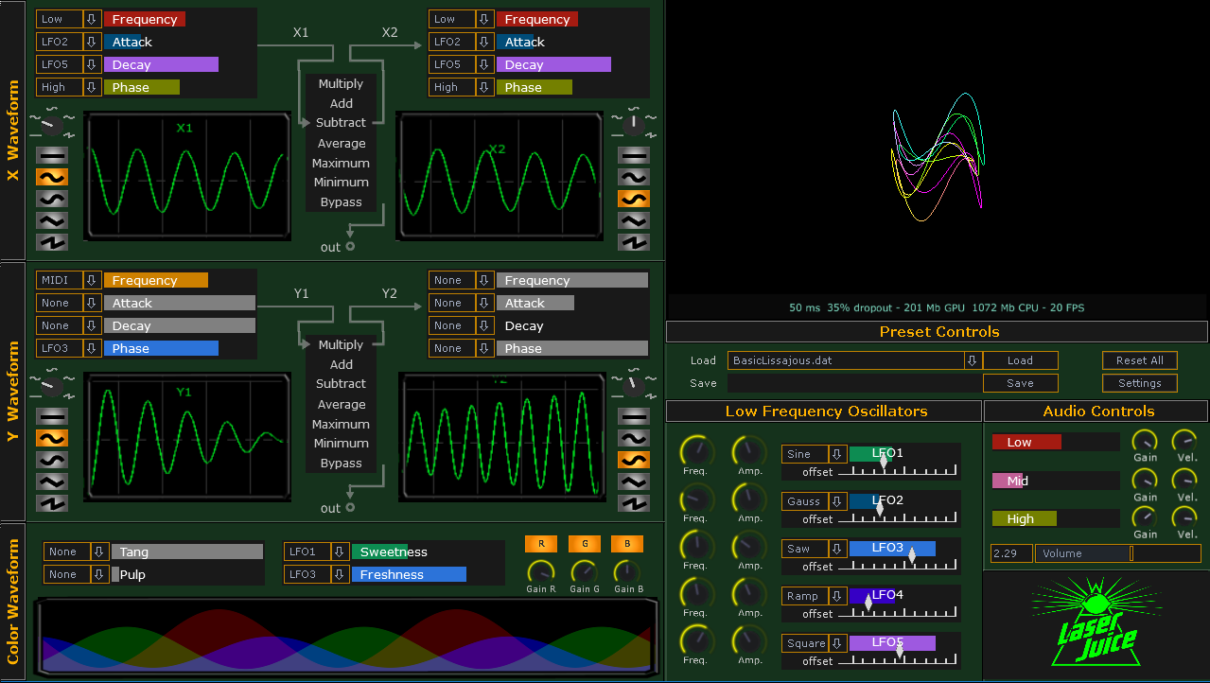

## **Safety:**

Laser Juice does have some built-in safety features, but ultimately it is up to the operator to take proper safety precautions when operating a laser of any kind.

### *Safety Kill-Switch*

Spacebar is the laser “kill switch”. Pressing spacebar at any time will stop laser output by cutting the ILDA and Audio DAC signal. Re-enable the laser by selecting the “Laser Active” checkbox in the settings window.

### *Laser Safety Zone*

In the settings window, you can set the size and position of the projection zone. The laser will not go outside these boundaries.

## **X and Y Waveforms:**

This is what determines how and where each line is drawn. The dimensions, X and Y, each have two separate waveforms: X1, X2 and Y1, Y2. The X1 and X2 (or Y1 and Y2) waveforms can be combined using different mathematical functions. Simply click on the function to change how the two interact (e.g. Multiply, Add, Subtract, Average, Maximum, Minimum, or Bypass). Bypass means the waves are not combined, and only the first (X1 or Y1) waveform is displayed. The shape of each waveform can be selected from a dial or a series of vertical buttons. These shapes can be one of the following: constant, sine, cosine, sawtooth, or ramp. 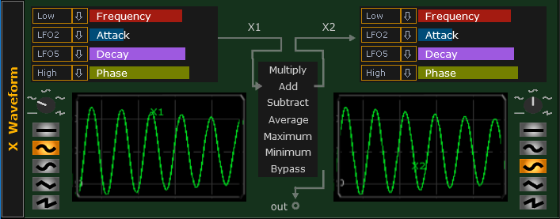

### *X and Y Waveforms can be Modulated*

In addition to the overall shape, each waveform can be modulated by assigning a modulator to one of four different parameters from the dropdown menus. These parameters are: Frequency, Phase, Attack, and Decay. Frequency is how often the wave is repeated. Phase is the particular position the waveform. Attack decreases the amplitude towards the beginning of the waveform, and decay decreases the amplitude towards the end of the waveform.

## **Color Waveform:**

This is what determines the color of the lines being drawn and uses the same general principles as the X and Y waveform. Tang is the overall brightness, or amplitude of the laser. Pulp is the frequency, or how often each cycle of color is repeated. Sweetness is the relative position of each color to its neighboring colors. Freshness is the overall phase of the entire pattern. 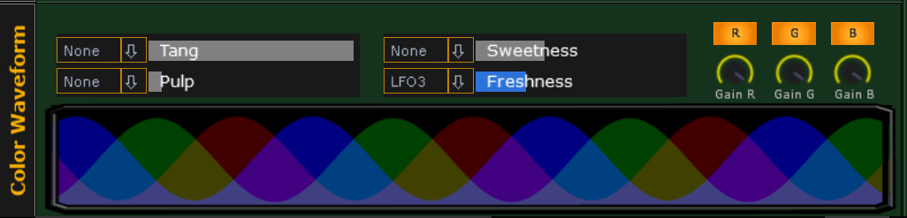

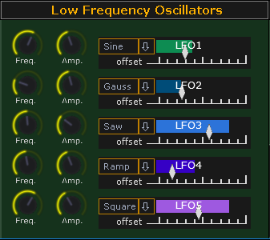**Low Frequency Oscillator (LFO’s) Modulators:**

Low Frequency Oscillators are values that sweep back and forth. They can be used to modulate any of the parameters for the X, Y, or color Waveforms. LFO’s, like other waveforms, have different shapes that dictate how these values sweep back and forth. These waveforms are selected from dropdown menus. The dials adjust the frequency and amplitude of each LFO and the offset diamond adjust the starting point of the LFO.

**Audio Modulators:**

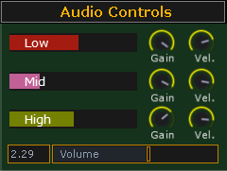Laser Juice is audio reactive. Just like LFO’s- the High, Mid, and Low modulators can be assigned to any of the X, Y, or Color waveform parameters. “Low” represents the power output of lower frequencies in the audio signal. Likewise, “Mid” and “High” represent the mid-range and high frequencies in the audio signal. Gain and velocity knobs help tune these modulators to your specific needs. Gain increases the relative amplitude while velocity increases the responsiveness of each one. Volume can be thought of the master gain, and increases the amplitude of all audio modulators evenly.

## **Preset Controls:**

If you find a particular pattern you like, you can save it. Just type in a unique name for your pattern and hit save. This will store a .dat file in the Laser Juice subfolder called Presets. You can manage your presets manually by copying, re-naming, or deleting these files when Laser Juice is not running. To load a saved preset, use the dropdown menu to navigate to a previously saved preset and then click load.

## **Settings:**

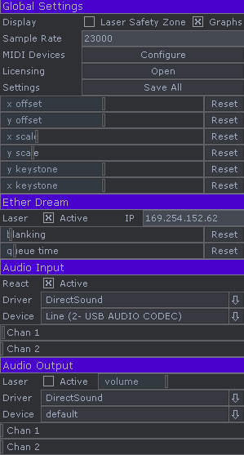In the settings menu, you can do everything from set the size and scale the laser safety zone to set up your audio or Ether Dream DAC. Understanding the settings window will be crucial for initial setup since settings will vary depending on the computer and laser projector used. See the “Initial Set-up and Calibration” section for details on how to calibrate for your specific equipment.

### *Global Settings:*

The Laser Safety Zone will display the boundary limits of the laser. Once enabled, you can adjust the geometry sliders below to set up your projection zone. Note, the laser will never go beyond these boundaries.

The “Graphs” checkbox toggles the X, Y, and Color Waveform graphs shown in the main window. Turning these graphs off decreases the load on the CPU which can be a useful option if your CPU can’t keep up (e.g. you experience laser dropouts).

The sample rate (or scan rate) is effectively how many points per second you are feeding the laser. **WARNING: Too high of sample rate can damage galvos. The creators of Laser Juice are not responsible for any damage to laser equipment.**

Save your settings. Once you find settings you would like to keep, hit the “Save All” button. Your settings will load automatically the next time you open Laser Juice.

### *Ether Dream:*

The “Active” checkbox will enable laser output via Ether Dream. If you are not using an Ether Dream DAC and are noticing the laser drop out intermittently, make sure this box in unchecked. The IP address should match what is found in the Ether Dream Diagnostics tool <https://ether-dream.com/downloads.html>.

The Blanking amount will eliminate any trail you see between the starting point and ending point of the pattern. Queue time is effectively the size of the Ether Dream buffer and should generally be set as low as possible. For initial set-up, it is helpful to have the Ether Dream Diagnostics tool running to examine the buffer size as you adjust queue time and sample rate. Too high of a queue time will max out the Ether Dream buffer and cause stuttering in the laser animation. Too low of a queue time and the Ether Dream buffer will run out causing the laser to cut out entirely for a moment until the buffer fills back up. The queue time should be adjusted so that the diagnostics tool shows under 1000 points in the buffer, or until the laser animation is smooth. Increasing sample rate will also help smooth out the laser animation.

### *Audio Input:*

The “React” checkbox enables Laser Juice to listen for audio going to your computer. If you are not using the audio input and you see the laser dropping out intermittently, make sure this box in unchecked. Once the checkbox is selected, you will be able to grab audio from audio devices and drivers. Selecting the right device and drivers will allow the “High”, “Mid”, and “Low” modulators to respond to audio. If you would like to play audio from the same machine, you will need to physically route the signal back to your computer by connecting a “line out/headphones” to a “mic/line in”. If you have an external audio device, you can plug patch cables from the sound card outputs to inputs, and use the headphone jack to listen.

### *Audio Output:*

Is used for capturing X and Y control signals with an audio device. In the future, sound card DACs will be supported.